# **Name: Abdurrahman Qureshi**

# **Roll No: 242466**

Practical No: 4

1) **Implementation of Bank Class using inheritance.**

CODE:

package EXP4;  
  
import java.util.Scanner;  
  
class BankBranch {  
 static String *IFSC_code* = "DCBL0000027";  
 static String *MICR_code* = "400072027";  
 static String *swiftCode* = "DCBLINBB";  
 static String *branchCode* = "000027";  
 static String *branchName* = "Byculla - Mumbai";  
 static String *address* = "Zainab Manzil, 108-110, Dr. Babasaheb Ambedkar Road, Byculla, Mumbai - 400 027";  
 static String *city* = "Mumbai";  
 static String *district* = "Mumbai";  
 static String *state* = "Maharashtra";  
  
 public static void showBranchDetails() {  
 System.*out*.println("Branch Name: " + *branchName*);  
 System.*out*.println("Branch Address: " + *address*);  
 System.*out*.println("Branch City: " + *city*);  
 System.*out*.println("Branch District: " + *district*);  
 System.*out*.println("Branch State: " + *state*);  
 System.*out*.println("Branch Code: " + *branchCode*);  
 System.*out*.println("Branch IFSC Code: " + *IFSC_code*);  
 System.*out*.println("Branch MICR Code: " + *MICR_code*);  
 System.*out*.println("Branch Swift Code: " + *swiftCode*);  
 }  
  
}  
  
class Bankuser extends BankBranch {  
 Scanner sc = new Scanner(System.*in*);  
 long acc_no = 0, temp;  
 String customer_name, customer_address;  
 double ROI = 0.08, initial_balance = 0;  
  
 public void createAccount() {  
 System.*out*.print("Please enter account number: ");  
 acc_no = sc.nextLong();  
 System.*out*.print("Please enter customer name: ");  
 customer_name = sc.next();  
 System.*out*.print("Please enter customer address: ");  
 customer_address = sc.next();  
 System.*out*.println("Account created successfully!");  
 initial_balance = 0;  
 }  
  
 public void deposit() {  
 System.*out*.println("Enter amount you wish to deposit: ");  
 long deposit = sc.nextLong();  
 initial_balance += deposit;  
 System.*out*.println("Amount deposited successfully!\nBalance: " + initial_balance);  
 }  
  
 public void withdraw() {  
 System.*out*.println("Enter amount you wish to withdraw: ");  
 long withdrawal = sc.nextLong();  
 initial_balance -= withdrawal;  
 System.*out*.println("Amount withdrawn successfully!\nBalance: " + initial_balance);  
 }  
  
 public void computeInterest() {  
 double amt = (initial_balance * ROI * 1);  
 System.*out*.println("Interest for initial balance after 1 years: " + amt);  
 }  
  
 public void displayBalance() {  
 System.*out*.println("Initial balance: " + initial_balance);  
 }  
  
 public void showAccountSummary() {  
 System.*out*.println("Branch Details: ");  
 System.*out*.println("Branch Name: " + *branchName* + "\nBranch Address: " + *address* + "\nIFSC Code: " + *IFSC_code*);  
 System.*out*.println("Customer Details: ");  
 System.*out*.println("Name: " + customer_name + "\nAddress: " + customer_address + "\nAccount Number: " + acc_no);  
 this.displayBalance();  
 }  
}  
  
public class bank {  
 static Scanner *sc* = new Scanner(System.*in*);  
  
 public static void main(String[] args) {  
 Bankuser[] user = new Bankuser[3];  
 int loop, n = 0;  
 for (int i = 0; i < user.length; i++) {  
 user[i] = new Bankuser();  
 }  
 do {  
 System.*out*.println("Please choose from the following menu:\n1.Create Account\n2.Deposit\n3.Withdraw\n4.Compute Interest\n5.Display Balance\n6.Display Account details\n7.Display Branch Details");  
 int choice = *sc*.nextInt();  
 long temp;  
 boolean found = false;  
 switch (choice) {  
 case 1:  
 user[n].createAccount();  
 n++;  
 break;  
 case 2:  
 System.*out*.print("Enter Account number: ");  
 temp = *sc*.nextLong();  
 for (Bankuser value : user) {  
 if (value.acc_no == temp) {  
 value.deposit();  
 found = true;  
 break;  
 }  
 }  
 if (!found) {  
 System.*out*.println("Account number does not exist!");  
 }  
 break;  
 case 3:  
 System.*out*.print("Enter Account number: ");  
 temp = *sc*.nextLong();  
 for (Bankuser bankuser : user) {  
 if (bankuser.acc_no == temp) {  
 bankuser.withdraw();  
 found = true;  
 break;  
 }  
 }  
 if (!found) {  
 System.*out*.println("Account number does not exist!");  
 }  
 break;  
 case 4:  
 System.*out*.print("Enter Account number: ");  
 temp = *sc*.nextLong();  
 for (Bankuser bankuser : user) {  
 if (bankuser.acc_no == temp) {  
 bankuser.computeInterest();  
 found = true;  
 break;  
 }  
 }  
 if (!found) {  
 System.*out*.println("Account number does not exist!");  
 }  
 break;  
 case 5:  
 System.*out*.print("Enter Account number: ");  
 temp = *sc*.nextLong();  
 for (Bankuser bankuser : user) {  
 if (bankuser.acc_no == temp) {  
 bankuser.displayBalance();  
 found = true;  
 break;  
 }  
 }  
 if (!found) {  
 System.*out*.println("Account number does not exist!");  
 }  
 break;  
 case 6:  
 System.*out*.print("Enter Account number: ");  
 temp = *sc*.nextLong();  
 for (Bankuser bankuser : user) {  
 if (bankuser.acc_no == temp) {  
 bankuser.showAccountSummary();  
 found = true;  
 break;  
 }  
 }  
 if (!found) {  
 System.*out*.println("Account number does not exist!");  
 }  
 break;  
 case 7:  
 BankBranch.*showBranchDetails*();  
 break;  
 default:  
 System.*out*.println("Invalid choice entered!");  
 break;  
 }  
 System.*out*.print("Would you like to continue with other operations?(Press 1 to continue)");  
 loop = *sc*.nextInt();  
 } while (loop == 1);  
 }  
}

OUTPUT:

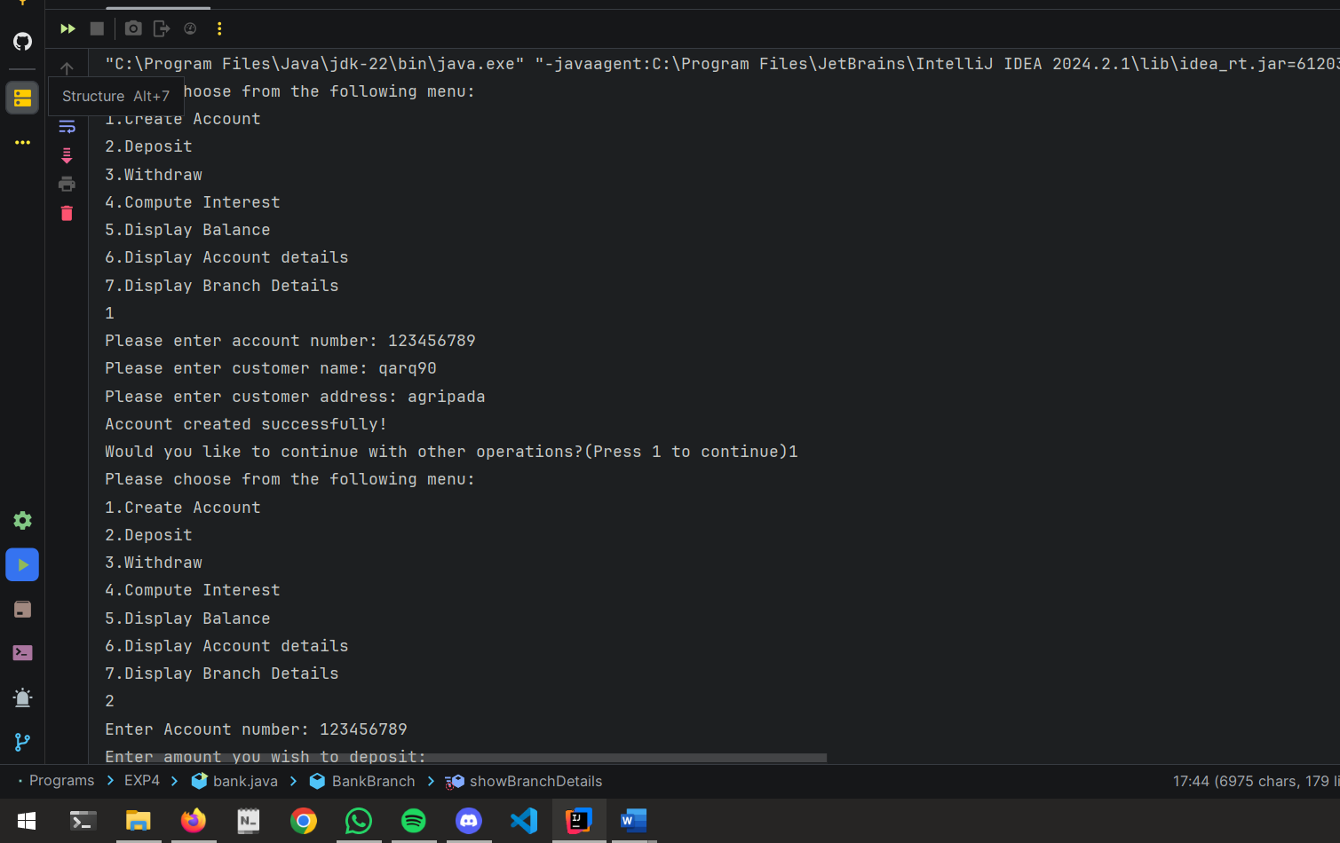

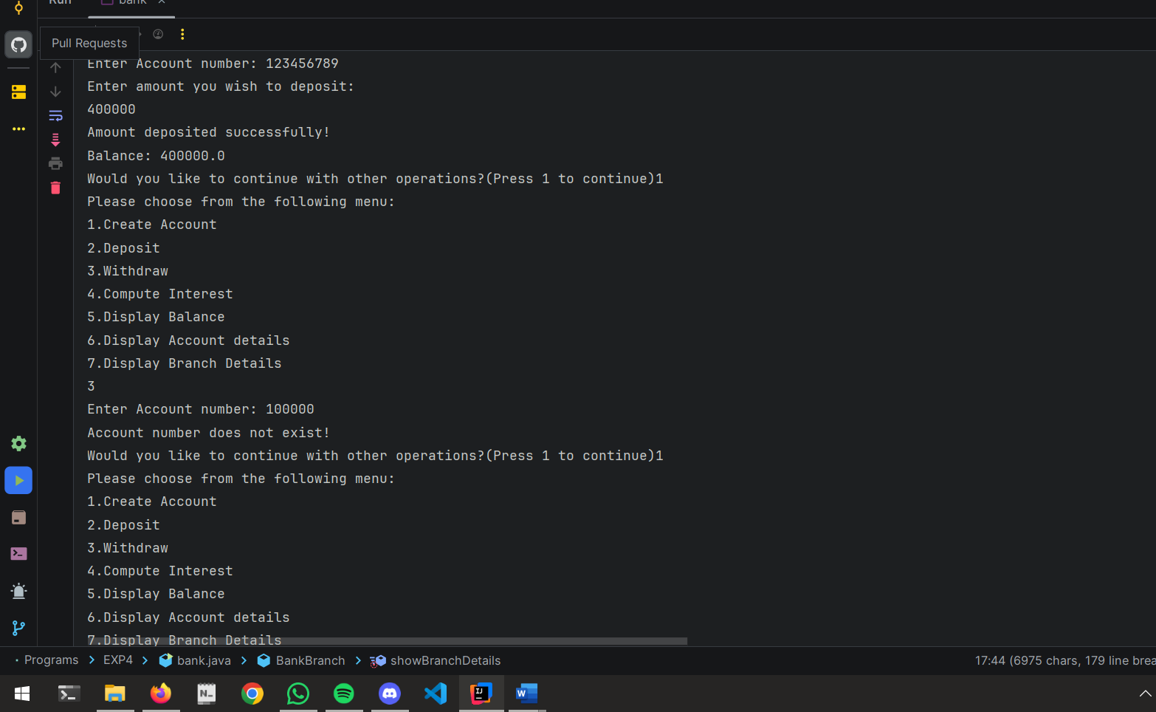

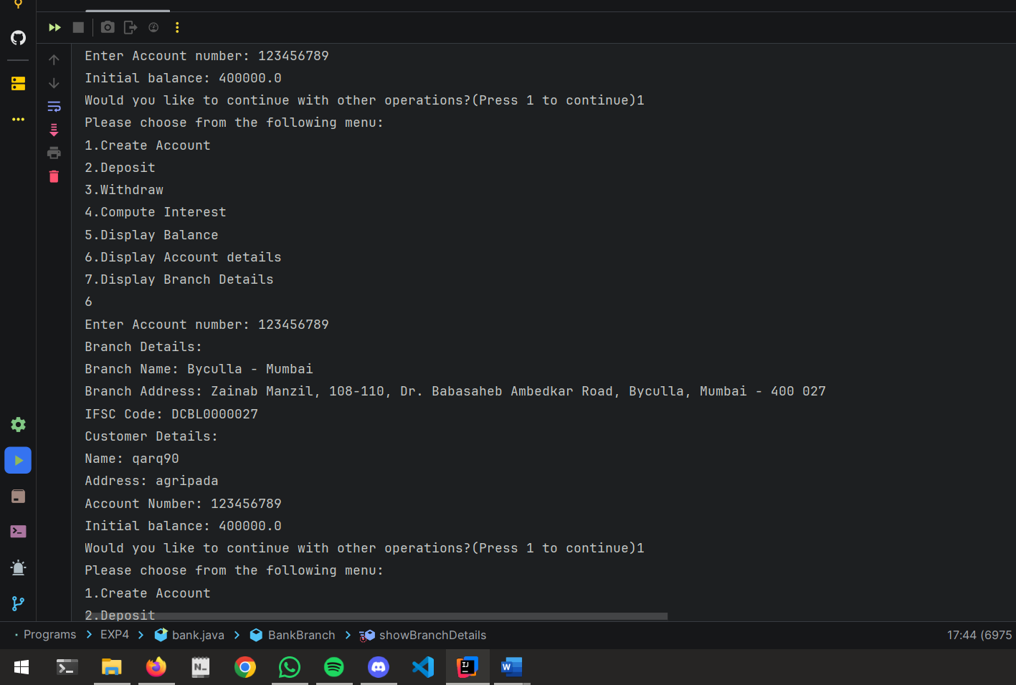

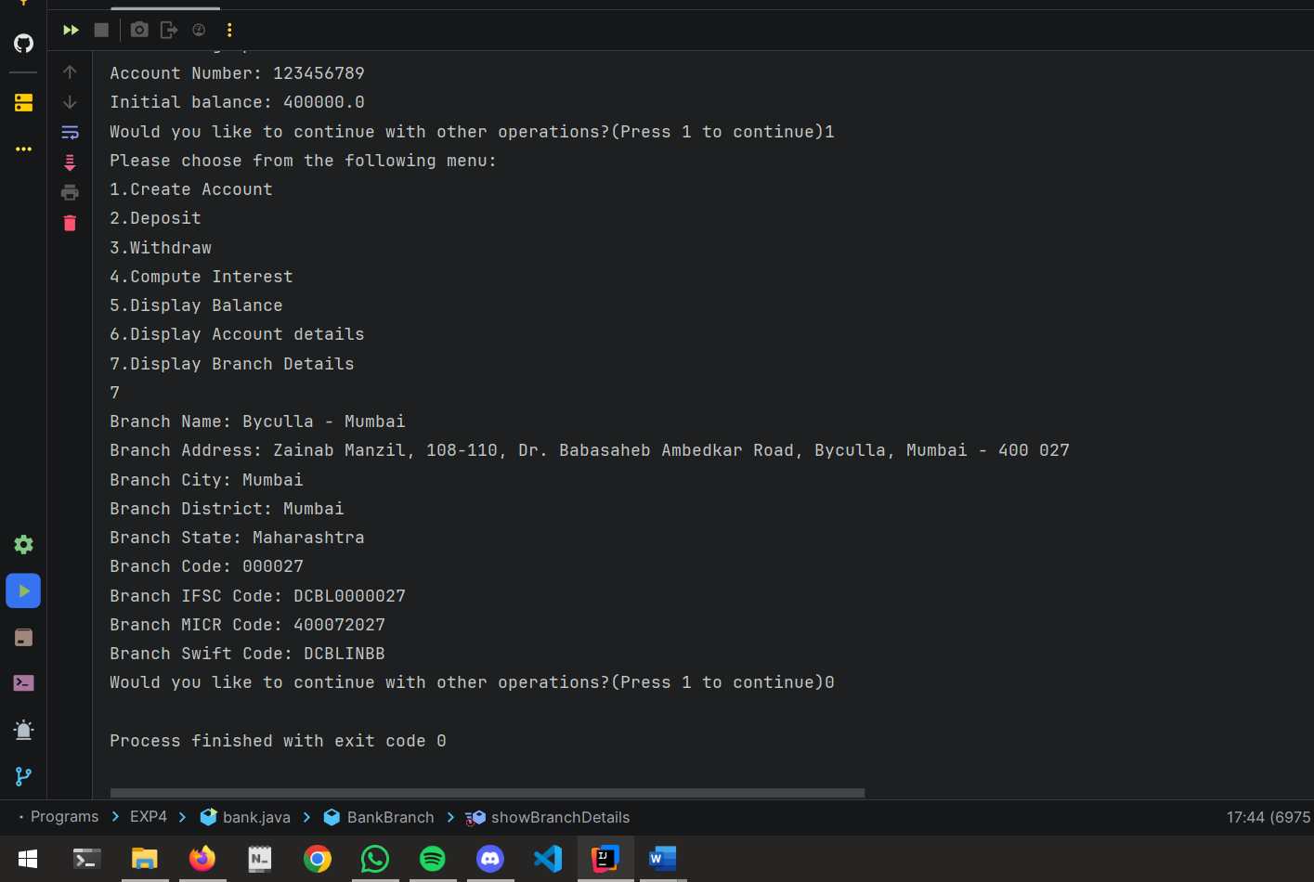

2) Implementation of currency Converter class using polymorphism.

CODE:

package EXP4;  
  
class CurrencyConverter {  
 public double convertToUSD(double amount) {  
 return amount;  
 }  
}  
  
class INRConverter extends CurrencyConverter {  
 @Override  
 public double convertToUSD(double amount) {  
 return amount * 0.012;  
 }  
}  
  
class EuroConverter extends CurrencyConverter {  
 @Override  
 public double convertToUSD(double amount) {  
 return amount * 1.1;  
 }  
}  
  
class YenConverter extends CurrencyConverter {  
 @Override  
 public double convertToUSD(double amount) {  
 return amount * 0.007;  
 }  
}  
  
public class currency {  
 public static void main(String[] args) {  
 CurrencyConverter inr = new INRConverter();  
 CurrencyConverter euro = new EuroConverter();  
 CurrencyConverter yen = new YenConverter();  
  
 double amountInINR = 1000;  
 double amountInEuro = 50;  
 double amountInYen = 5000;  
  
 System.*out*.println("INR to USD: " + inr.convertToUSD(amountInINR));  
 System.*out*.println("Euro to USD: " + euro.convertToUSD(amountInEuro));  
 System.*out*.println("Yen to USD: " + yen.convertToUSD(amountInYen));  
 }  
}

OUPTUT:

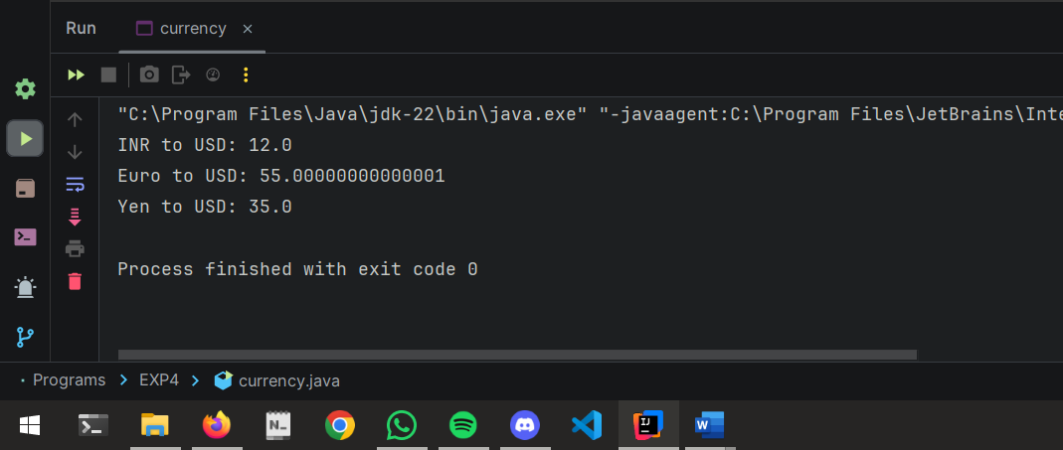

3) Implementation of MCQ class using interface and Abstraction.

CODE:

package EXP4;  
  
import java.util.Scanner;  
  
interface Question {  
 void displayQuestion();  
  
 boolean checkAnswer(int userAnswer);  
}  
  
abstract class AbstractMCQ implements Question {  
 String question;  
 String[] options;  
 int correctAnswer;  
  
 public AbstractMCQ(String question, String[] options, int correctAnswer) {  
 this.question = question;  
 this.options = options;  
 this.correctAnswer = correctAnswer;  
 }  
  
 @Override  
 public void displayQuestion() {  
 System.*out*.println(question);  
 for (int i = 0; i < options.length; i++) {  
 System.*out*.println((i + 1) + ". " + options[i]);  
 }  
 }  
  
 @Override  
 public boolean checkAnswer(int userAnswer) {  
 return userAnswer == correctAnswer;  
 }  
}  
  
class SimpleMCQ extends AbstractMCQ {  
 public SimpleMCQ(String question, String[] options, int correctAnswer) {  
 super(question, options, correctAnswer);  
 }  
}  
  
public class MCQ {  
 public static void main(String[] args) {  
 Scanner scanner = new Scanner(System.*in*);  
  
 String[] options1 = {"7 - 1", "4 - 2", "5 - 3", "6 - 4"};  
 SimpleMCQ mcq1 = new SimpleMCQ("What is 2 + 2?", options1, 2);  
  
 String[] options2 = {"Paris - 1", "Hell - 2", "Toilet - 3", "Fire - 4"};  
 SimpleMCQ mcq2 = new SimpleMCQ("What is the capital of France?", options2, 1);  
  
 int score = 0;  
  
 mcq1.displayQuestion();  
 System.*out*.print("Your answer (1-4): ");  
 int userAnswer1 = scanner.nextInt();  
 if (mcq1.checkAnswer(userAnswer1)) {  
 System.*out*.println("Correct Answer!");  
 score++;  
 } else {  
 System.*out*.println("Wrong Answer!");  
 }  
  
 mcq2.displayQuestion();  
 System.*out*.print("Your answer (1-4): ");  
 int userAnswer2 = scanner.nextInt();  
 if (mcq2.checkAnswer(userAnswer2)) {  
 System.*out*.println("Correct Answer!");  
 score++;  
 } else {  
 System.*out*.println("Wrong Answer!");  
 }  
  
 System.*out*.println("\nYour total score: " + score + "/" + 2);  
  
 scanner.close();  
 }  
}

OUTPUT:

